Kojagiri Pournima – DSPPL Full Moon Session Synopsis of Session on 09th Oct 2022
Topic- “Role of Ancient Rituals in Overall Personality Development”
About distinguished & most admired Speaker of the Session
Speaker Aditya Abhyankar is BE (E&TC), completed his M.S. & Ph.D. From Clarkson University in USA, also completed his second Ph.D. in Sanskrit (Vedant). He is also M.A., MBA Finance. He has won prestigious awards Like Sir C V Ramana Award 2015. He has 8 US patents, 14 Indian patents under his belt. He has participated in many research projects of various universities. He was closely associated with the Aadhar enrolment project of Govt of India.
Background of the Session
Over the years, new Gen-X or Gen-Z generation (millennials) are quite curious & inquisitive about reasoning & justification of ancestral rituals & religious practices.
It’s a need of hour -to understand & spread the word of scientific basis, relevance & usefulness of the same to have more logical & wholehearted adaption.
Key Take Aways of interactive Q&A session
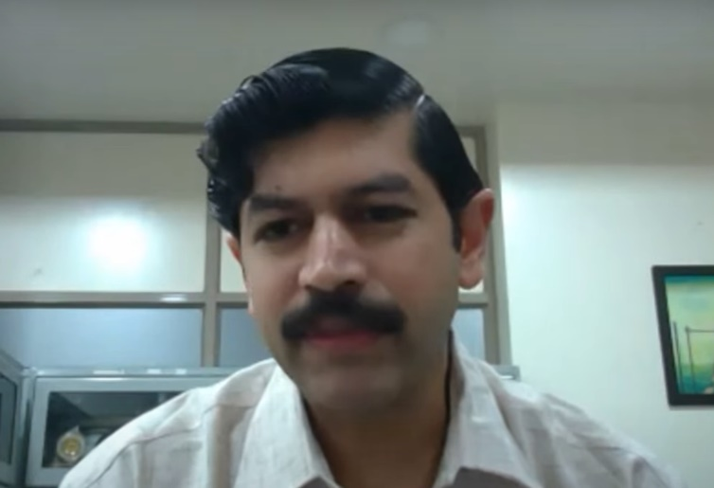
Interesting facts about Dharma ( It’s not a religion as perceived)
Uniqueness of Sanatan Hindu Civilisation -Dharma
Religion has a very narrow connotation in modern times restricted to faith one follows. While Dharma is much wider in its sense & means “righteousness & a path which upholds ethical & moral values in the life”
सर्वेSपि सुखिनः सन्तु.. सर्वे सन्तु निरामया.. Core Thinking of the dharma is “All Inclusive & Global”. It prays for well being of all living creatures & not restricted to particular section of society or merely humans.
The Hindu dharma is not compulsive & suggestive incl. the rituals- so it’s truly democratic in its sense.
Our literatures are mostly in the form of dialogue & interactive between Guru & seeker- making it a two way communication promoting questions from seeker & wise answers by the Guru. (“गुरु शिष्य संवाद” a foundation of research based scientific literature)

If we compare the latest british education system that focused on memorization but overlooked on comprehension, research- analysis & further improvisation. This was obviously what suited them the best for ruling the slave country.

Vivekanand had once said that – “ by learning within british education system- at the end of the first day – anybody will create an impression that your parents are fools. Learning it for a month would develop an illusion that your nation is not making sense and after learning it over a year – one would create a mindset that not only this but also your ancestors are totally fool…”

On the contrary, surprisingly- the then prevailing Gurukul System in India was based on Interactive & experimental & patient learning with Guru.

These rituals are meant for upliftment of both material & spiritual domains of life.

In ancient times such rituals were scientific. They became semi scientific in the medieval era & in modern times -these are totally blind in observance.

Yadnya - Selfless karma for the nature, for the society, for the Nation
‘Yadnya’ is Selfless karma which is beyond your own self, its karma for the betterment of society & country as a whole while nurturing the nature- flora & fauna.

Foundation of all rituals i.e. yadnya (यज्ञ ) is sacrifice of self interests & self priorities वैयक्तिक स्वार्थ आणि सुविधा का त्याग

Truth about the Varna System (वर्ण व्यवस्था ) &
Its total dis-connect from Caste System enforced by the Foreign Invaders
Four Varna (वर्ण ) are not referring to any caste system in either form – but they are scientific segregation of duties based on your ‘profession’.
So called- ‘Caste System’ somewhat imposed by British rulers in their master policy of “Divide (the minds -hearts) & Rule (the all)”

Varna Vyavastha illustrations in modern time professions-
Research, Dissemination of Knowledge & nurturing the talent -which in modern days the role of Scientists, Teachers/ professors etc. were known to be “Brahmin”,
While the every soldier standing for the security of the country is “Kshatriya”,
all members community as traders, service providers/ businessmen are “Vaishya”
while all other supporting members like artists etc. in the society are “Shudra”.

MOST IMPORTANTLY – Shudra (शूद्र) is not the same as Kshudra (क्षुद्र).

Different rituals are designed differently for all four Varna in their respective four Ashram (phases of individual life) Brahmacharya Ashram, Grihasth Ashram, Vanprastha Ashram & Sanyas Ashram.

Covering few rituals & their relevance in a time bound session
a. Yadnya Karma
b. Upawas – Fasting
c. Pradakshina
d. Rituals in marriage
e. Greeting anyone by saying “Namaste”
f. Background of restrictions on Saguna Puja for women during Menstrual Cycle, reasons & relevance & alternatives in current times like performing Nirguna Puja.

Challenges emerged over the centuries of Foreign Invasions & Way Forward
With back-to-back invasions in the last 9 centuries targeting forced religious conversions & slavery - it’s must be noted that our ancient rituals were made to go blind. Processes (Rituals) have lost ‘a connect with the principle’.

Over the centuries - Blind observance of these rituals has stretched a “Line of Ignorance”
and it’s on us to draw the bigger “Line of Understanding & Awareness”.

It’s on parents & elderly family members to follow these rituals with understanding the principle, practice is sincerely to reap the benefits of the ancient scientific treasure we inherited. Our actions would speak louder than mere preaching.

The session concluded with the audience requesting a couple of more sessions of the speaker in the near term.

Complete session is available on
YouTube channel “DSPPL Devrukh” & website www.dsppl.in

